## ***Project Overview***

This product is a robot with the capabilities of traveling across the entire endurance course in room HH208. The intended audience is the professor and students of CS-104 01.

## ***Purpose and Scope of this Specification***

Programming of robot to travel the endurance course in room HH208. Intended audience are the professor and students of CS 104 01.

## ***Product Context***

The product relates to other robots, in that its sole purpose is to travel a layout course in room HH208 and help CS 104 students further understand problem solving. It is independent and self contained. It interfaces only within its own system. It programming a simple block code language in comparison to other AI robots that are being created using python mainly.

## ***User Characteristics***

N/A, we have no customers.

***Gantt Chart***

[Sprint 1 Endurance Gantt project plan Template (1).xlsx](https://docs.google.com/spreadsheets/d/1DQuLxf5cnCCgInL9dDu7eOQ7UlNG6305/edit#gid=226517277)

## ***Assumptions***

Robots functionality will likely be overall better if it has a consistent speed.

Robot will more accurately travel the path if it stops and delays before turning likely.

## ***Constraints***

* Project must be done using the Sphero robot only
* Only language allowed is block code
* Lack of actual security for the software

## ***Dependencies***

* Endurance course layout is a series of 4 straight lines.
* Sensor data that we must submit at the end has to resemble a rectangle
* Project’s due date is November 3rd midnight

***Requirements Chart***

| **Req#** | **Requirement** | **Comments** | **Priority** | **Date Rvwd** | **SME Reviewed / Approved** |
| --- | --- | --- | --- | --- | --- |
| ENDUR_01 | Must accurately circumnavigate the entire endurance course | N/A | 1 | 10/22 | 10/22 |
| ENDUR_02 | Must travel in a straight line certain specific distances distance | N/A | 1 | 10/22 | 10/22 |
| ENDUR_03 | Must be able to stop at certain positions | N/A | 1 | 10/22 | 10/22 |
| ENDUR_04 | Must be able to turn, after stopping, then continue moving. | N/A | 1 | 10/22 | 10/22 |
| ENDUR_05 | Must stop after accurately traveling the entire endurance course | N/A | 1 | 10/22 | 10/22 |
| ENDUR_06 | Robot at the start of endurance course before moving, must show a greenlight, and speak, “ready, set, go.” | N/A | 1 | 10/22 | 10/22 |
| ENDUR_07 | Robot at the end of endurance course, after coming to a stop, must show a redlight, and say, “I’m done and I need water.” | N/A | 1 | 10/22 | 10/22 |
| ENDUR_08 | Robot must be fully designed to complete all previously stated requirements by Nov 3 | N/A | 1 | 10/22 | 10/22 |
| ENDUR_09 | Robot should travel at consistent speed throughout | N/A | 3 | 10/22 | 10/22 |

### **Protection**

Lead Programmer’s Sphero account with the block code will have a complex password. Sphero will only be signed into lead programmers phone to minimize chance of access leaking. Password for lead programmers Sphero account will be changed weekly. Sphero will be recorded and looked over to ensure that its path traveled matches to sensor data, to ensure there are no errors in our data recording.

### **Authorization and Authentication**

Authorization for access to software must be obtained directly from the lead programmer. Any changes must first be checked with the lead programmer.

***Requirements Confirmation Sign Off***

| **Meeting Date** | **Attendees (name and role)** | **Comments** |
| --- | --- | --- |
| 11/03/22 | Azeez Olapade Lead Programmer / Tester | N/A |
| 11/03/22 | Biyi Abass Lead Data Manager / Recorder | N/A |
| 11/03/22 | Sekou Diabate Assistant Tester / Data Manager | N/A |

***Algorithm***

* Program Start
* Robot will light up the color green, and speak, “ready, set, go”.
* Robot will travel a straight line of 22’
* Robot will turn, and then travel a straight line of 11’8”
* Robot will turn, and then travel a straight line of 21’6”
* Robot will turn, and then travel a straight line of 11’11”
* Robot will light up the color red
* Robot will stop moving
* Robot will say, “I’m done, and I need water”.
* Program End

***Flow Chart***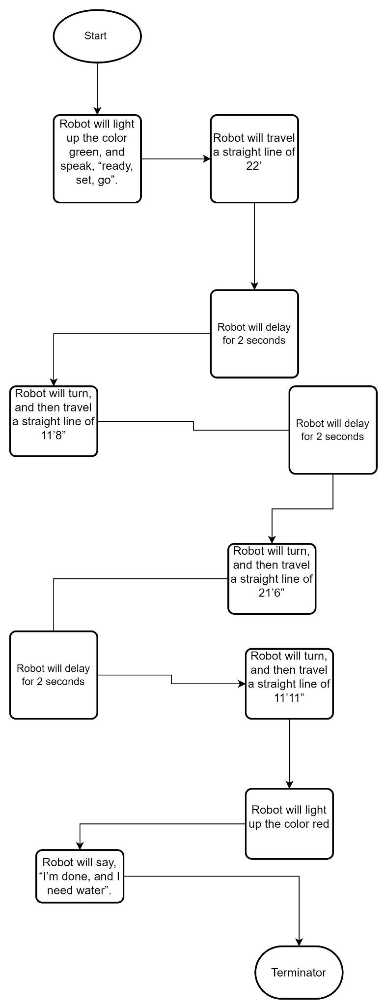

## ***Software***

The software language being used to develop this program is called block code which was originally translated from java functions. The platform this is deployed on is Sphero Edu, which is connected to our robots via bluetooth

## ***Hardware***

The hardware platform that was used is called Sphero Sprk+.

***Block Code***

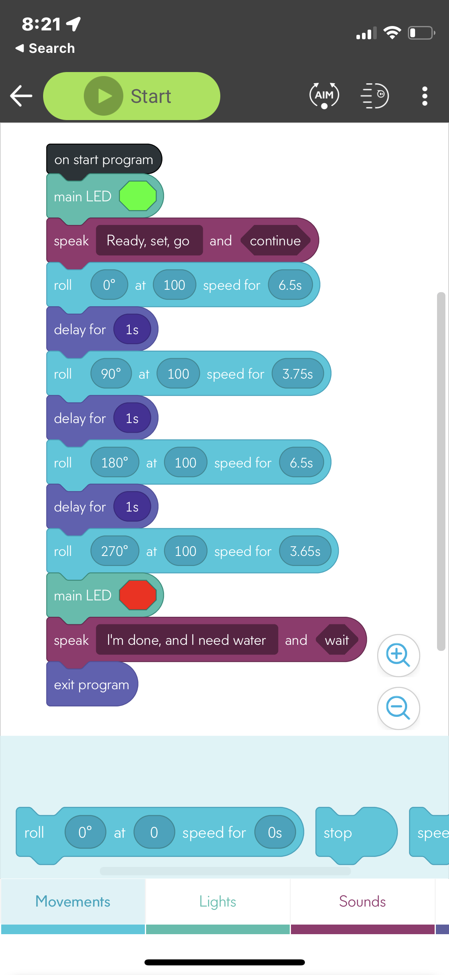

***Sensor Data Diagram***

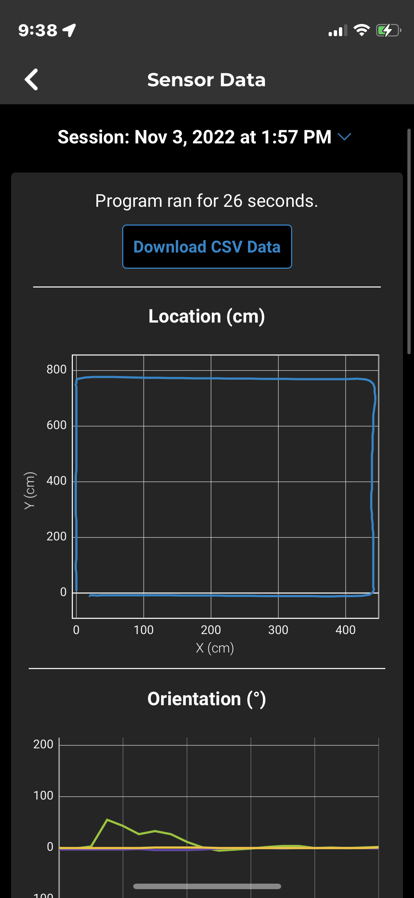

***Test Table***

| **Reason for Test Case** | **Test Date** | **Expected Output** | **Observed Output** | **Staff Name** | **Pass/Fail** |
| --- | --- | --- | --- | --- | --- |
| To determine the distance the robot will travel at a speed of “100” over 4 seconds, to get the first straight line down | 11/3 | 22 feet | 11’3 feet | Azeez | N/A |
| To determine the distance the robot will travel at a speed of 100 over 3.8 seconds | 11/3 | 10’10 feet | 10’11 | Azeez | N/A |
| To determine the distance the robot will travel at a speed of 100 over 6.5 seconds | 11/3 | 22 feet | 22 feet | Azeez | N/A |
| To determine the distance the robot will travel at a speed 100 over 3.7 seconds | 11/3 | 10’8 feet | 10’9 feet | Azeez | N/A |
| To determine the distance the robot will travel at a speed 100 over 3.65 seconds | 11/3 | 10’8 | 10’8 feet | Azeez | N/A |
| To determine whether the current time values on the block code for each side is enough to accurately travel the course | 11/3 | Accurately travel the course | Far long end was a bit off, was overshot, far short side was off too, time on third and fourth block evidently need to be reduced | Azeez | Fail |
| To determine whether the modified time values on the block code for each side is enough to accurately travel the course | 11/3 | Accurately travel the course | Was much better, however minor changes still need to be made, far long end possibly shortened a bit more as well as robot can be angled better | Azeez | Fail |
| To determine whether the modified again time values on the block code for each side is enough to accurately travel the course | 11/3 | Accurately travel the course | Accurately traveled the course | Azeez | Pass |
|  |  |  |  |  |  |
|  |  |  |  |  |  |
|  |  |  |  |  |  |

***Staffing Plan***

| Name | Role | Responsibility | Reports To |
| --- | --- | --- | --- |
| Azeez | Lead Programmer / Tester | To develop the algorithm that the block code will follow, and to make revisions to either accordingly. Also to test the robot in order to ensure that the code was done accurately. | No one. |
| Sekou | Lead Data Manager / Recorder | To convert the algorithm into a flow chart, and also to record test data. Data manager also maintains System Design Document, and as well as that records the finished project in the robot video. | Azeez |
| Biyi | Assistant Tester/Data Manager | Doesn’t have a task to himself mainly, but assist other group members along in their jobs, giving insight, and also suggesting his own ideas and work to main project | Azeez |